1. Log in to Salesforce Org
2. Click on the gear icon and click on setup
3. Go to Object Manager and Search for Product Object
4. Then in Product Object go to page Layouts
5. Select any One of the Page Layout in which you want to add the Product Configuration Visualforce Page (Note – With the help of Page Assignment you can find which layout is in Use)
6. Once Page Layout is open
7. 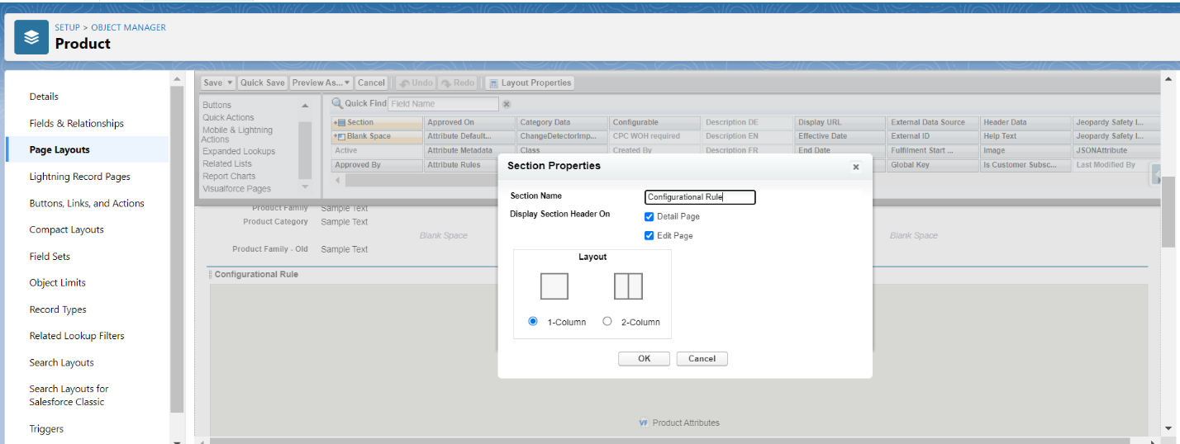Drag a section element to the canvas so that VF page can be added in that specific section, You can name that section anything based on the requirement
8. After that go to Visualforce pages section and search for ‘Product Attributes’ and drag it to the section which you had created above

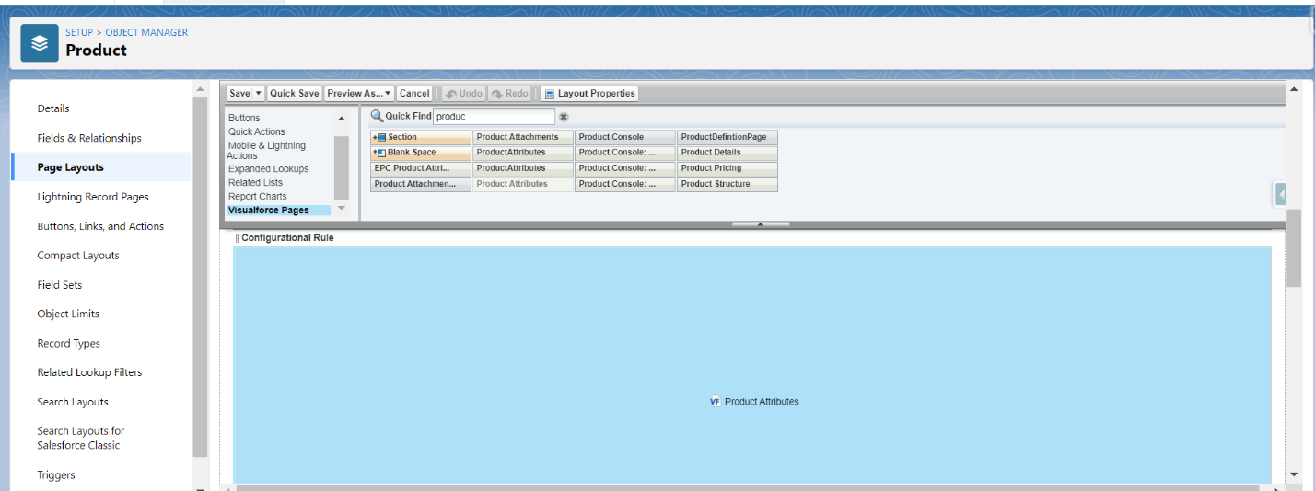

1. Then based on the requirement you can set the configuration (height, width etc.) of the VF
2. Then Click on Save
3. Then the Configuration VF will be added in your product page and it can be seen there

